# Lab 7. Document generation with the Word Connector

**Author:** Serge Luca aka “Doctor Flow”

**Learning objective:** create a Flow that will generate an invoice (in PDF) based on a Word template and based on data stored in an Excel document.

**Duration:** 30 minutes

**Scenario:** Excel files containing invoice data are stored in OneDrive for Business. A Flow will read these data, it will parse the data, and it will generate an invoice based on a word document template. The invoice will be transformed into a PDF file.

**Prerequisites**: The Word Connector is a Premium connector. You need to test this lab with a trial premium subscription.

When using the Word Connector, the designer will ask you to start a premium trial or you must have activated the Community license (see lab 0).

The files for the lab can be downloaded from the lab GitHub : the file name is

## Tasks:

1. Upload the file **invoice.xlsx** provided by the trainer to the Documents folder of your OneDrive for Business
2. Look at this file: there are 2 tables:
   1. The table **invoice** consists of the invoice headers
   2. The table i**nvoicelines** consists of the invoice lines
3. Each table has a name that we will reference from our Flow; to find out the table name, open the file in Excel desktop, click the table and select the menu Design as illustrated in the next picture:

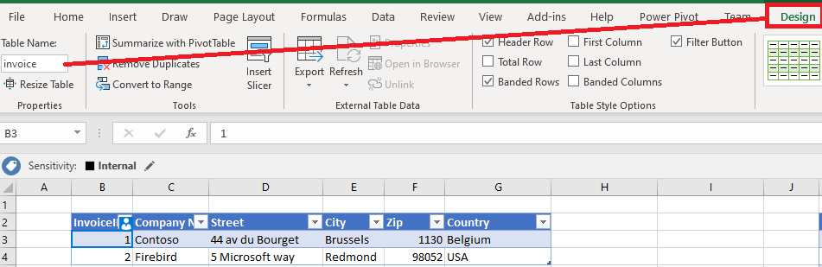

1. Each invoice can have several lines.
2. Upload the file **Invoice Template start.docx** provided by the trainer into the Documents folder of your OneDrive for Business and take a look at this file:

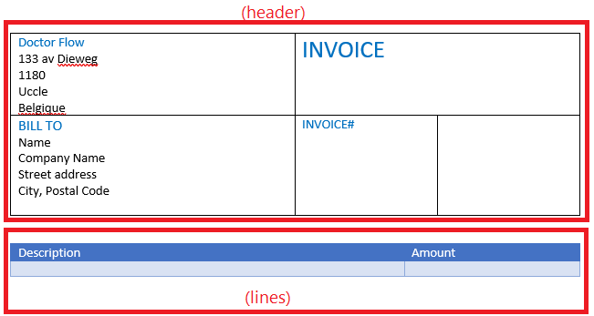

The section “header” and “lines” are 2 different tables. The lines section is a table with one row for the header and one row for the data.

1. Go to the Word options, select Customize Ribbon, select **Developer**, and click OK.

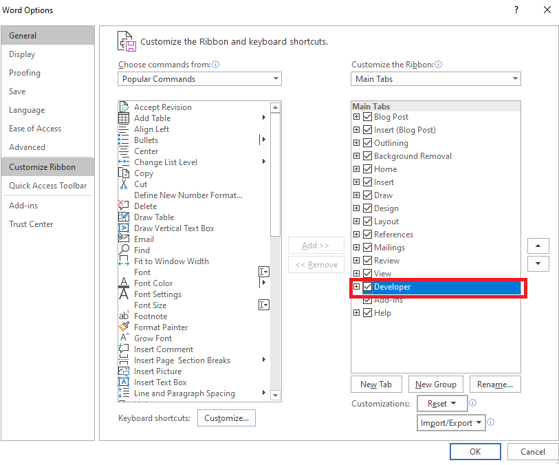

This will display the **Developer** tab in Word:

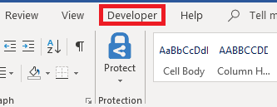

1. You will customize the word template, next to each field of the template, we will add a **Word plain text content** control, and we will use the properties button to name them accordingly.

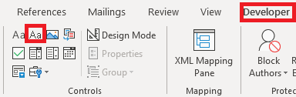

1. Add a control next to the following fields: **Company Name**, **Street address**, **City** (add 2 controls here, one for the city, one for the zip code) and one next to **invoice#;** with the properties button, name (Title of Property) the controls **company**, **street**, **City**, **zip**, **invoiceid** as illustrated below:

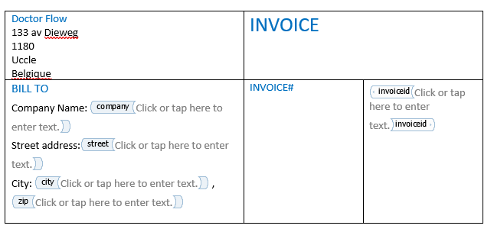

1. You will focus now on the invoice lines; select the second row of the table (the one with the empty data, not the row with the header); select the whole row (including the 2 columns) and add a **Repeating Section Content Control**:

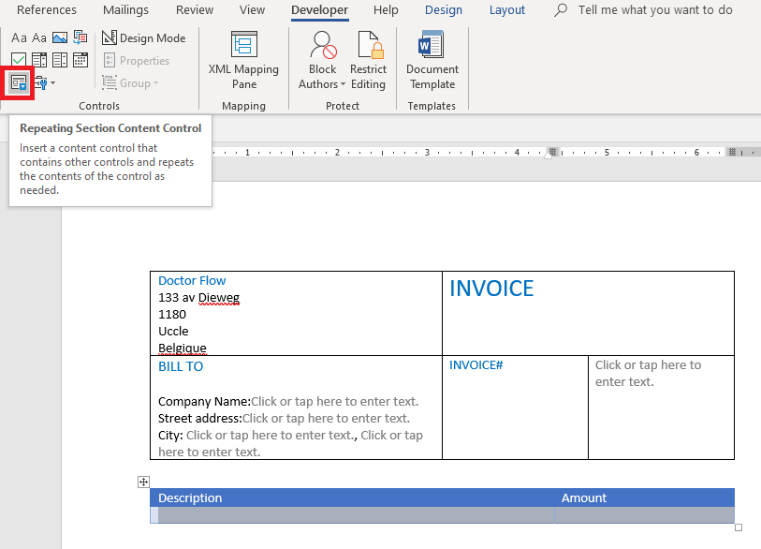

1. In this repeating section, content control, add 2 Plain text content controls and named them **Product** and **Amount**:

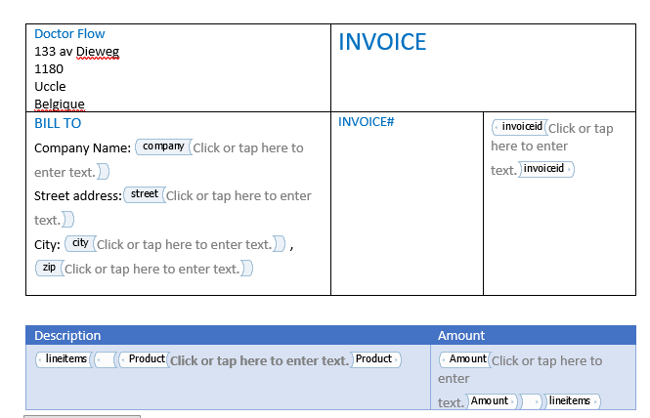

1. Just after the repeating section add a **Picture content control** that will display the manager signature. Name this control **managersignature**.
2. Eventually, the template should look like this:

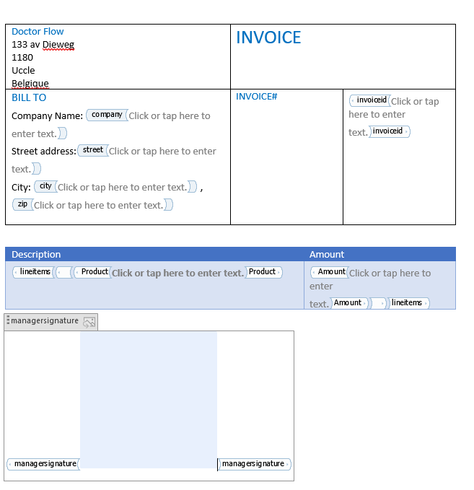

1. Rename the file to **Invoice template**.docx
2. Let’s create Flow that starts from a button (Instant cloud flow > Manually trigger a flow).
3. Add an action **Excel Online (Business)-** **List rows present in a table** , rename it as **Find Invoices** and retrieve the **invoice table** of your **invoice.xlsx** documents:

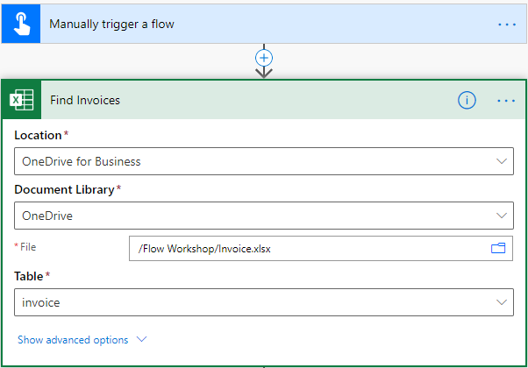

1. For each invoice, you will find the corresponding invoice lines: add the **Apply to each** action where you will add another **Excel Online (Business)-** **List rows present in a table** (rename it **Find InvoiceLines**) that will retrieve the invoicelines table:

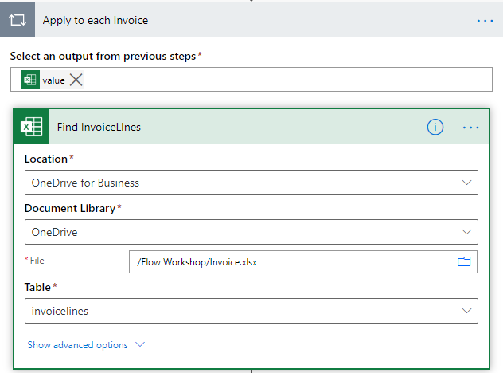

In the Excel for business action

1. You need to filer the retrieved lines. Click the **Show advanced options** and in the **Filter Query** field, type **Invoice eq.‘’**

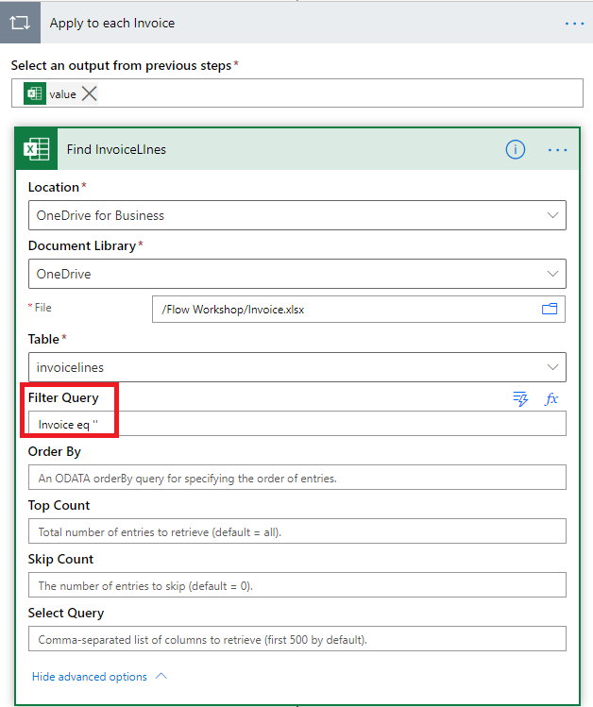

1. Move the cursor between the ‘’ and add the expression **items('Apply_to_each')['InvoiceID']** then click ok:

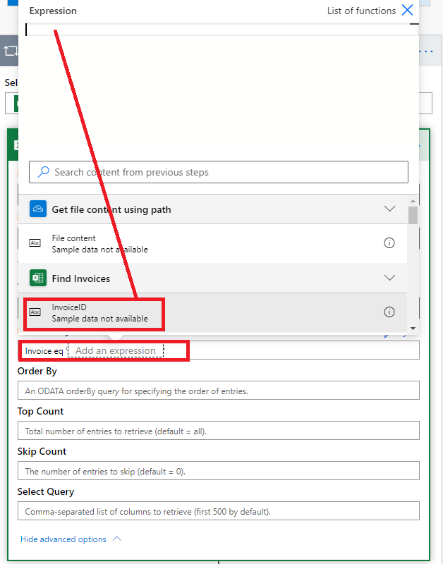

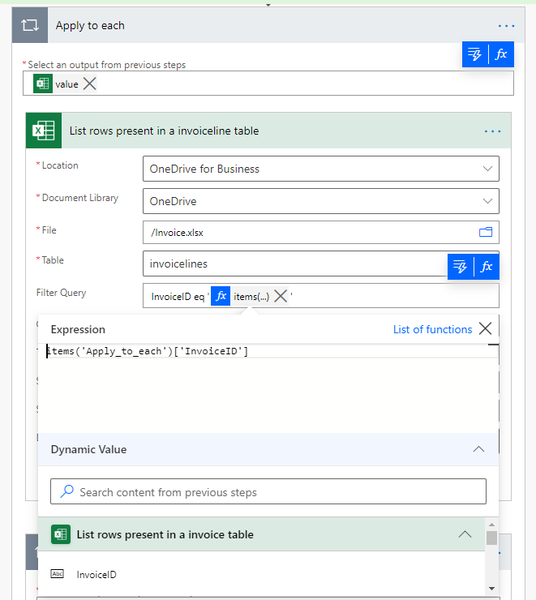

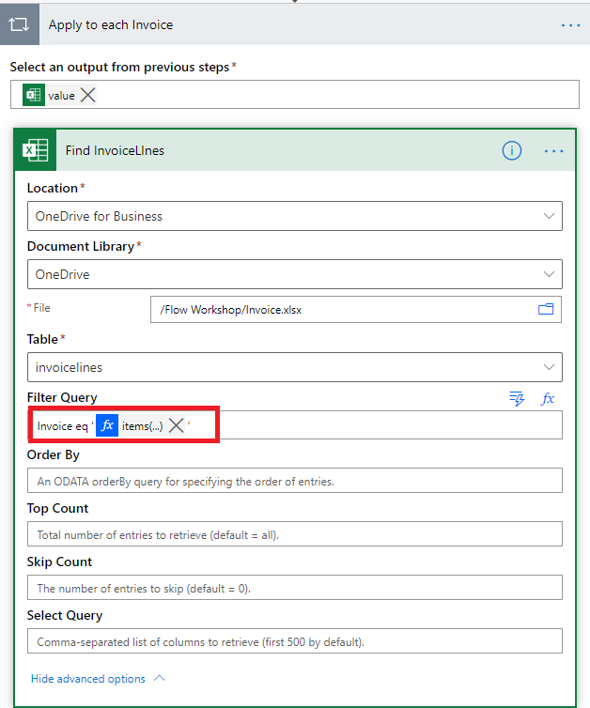

1. Add an action **Populate a Microsoft Word template,** and you will notice that the Word content controls show up as fields in this connector; fill in the field with the Excel values:

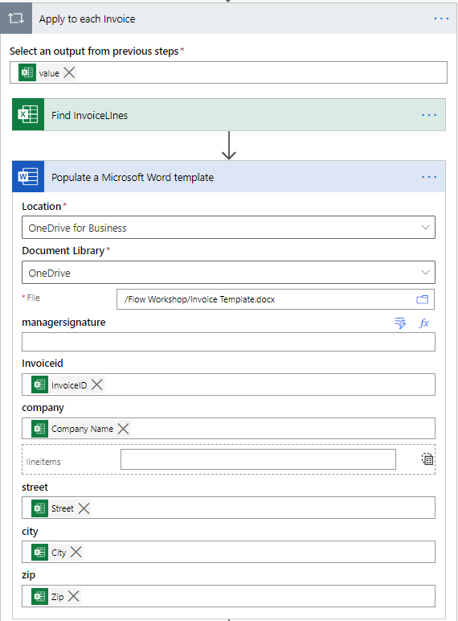

1. You still have to generate a file in OneDrive for Business with the content of the previous action output content: add a **OneDrive for Business Create file** action and rename it Create Word file.
2. Fill in the File Content from with the output of the previous action and dynamically generate the file name:

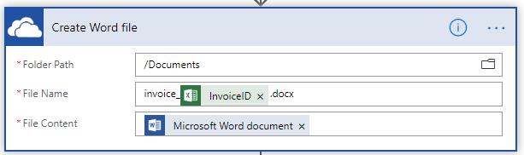

1. Add an action Convert Word Document to PDF and grab the path of the generated file
2. Add a **OneDrive for Business Create file action** to create the pdf file and pass the body of the previous action. The next 2 actions should look like this:

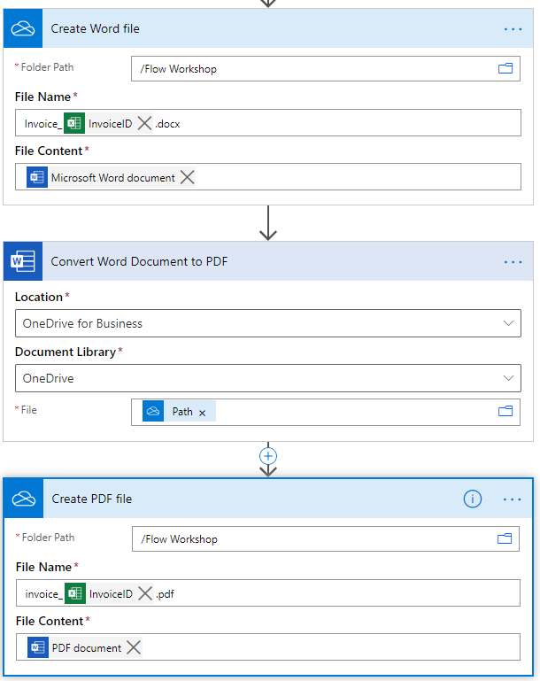

1. Run the Flow and check the generated PDF files. The first file should look like this:

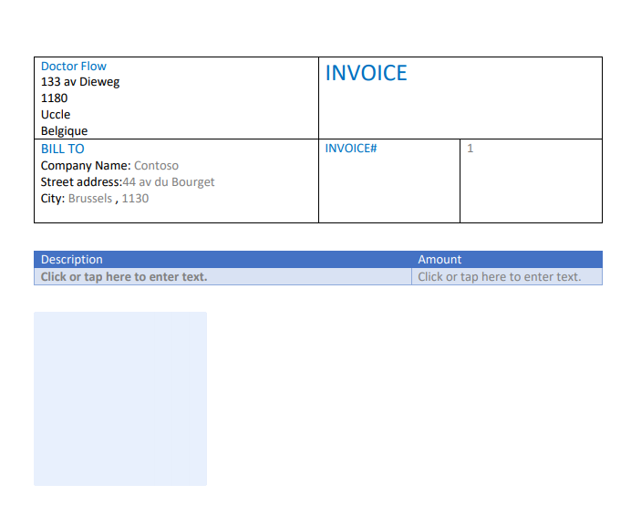

1. You will now update the Flow to implement the line items. Edit the Flow and define an array variable called **invoiceLines** and initialize it as an empty array:

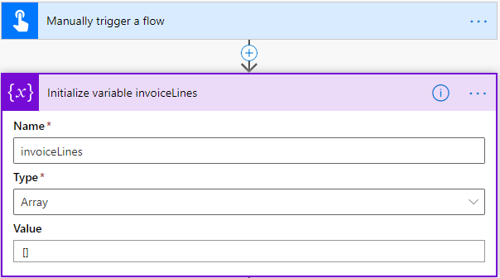

1. Add a Set variable action at the start of Apply to each to clean-up this variable again:

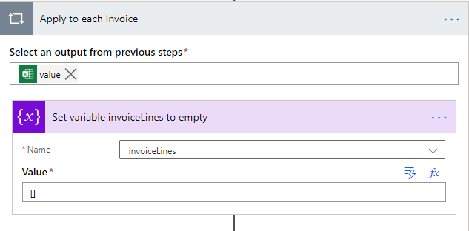

1. After the Find **InvoiceLines** action, **add an Apply to each Invoice** to go through every invoice lines:

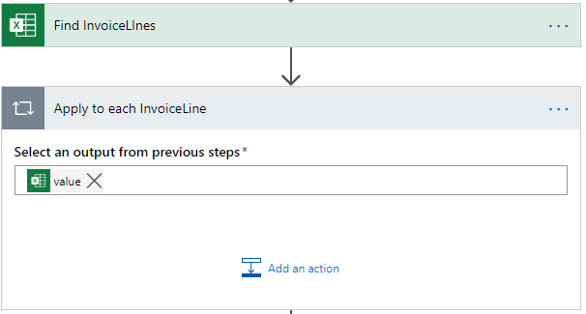

1. In this Apply to each, you will create a JSON array containing the **lineitems** information; add an **Append to array variable** action:

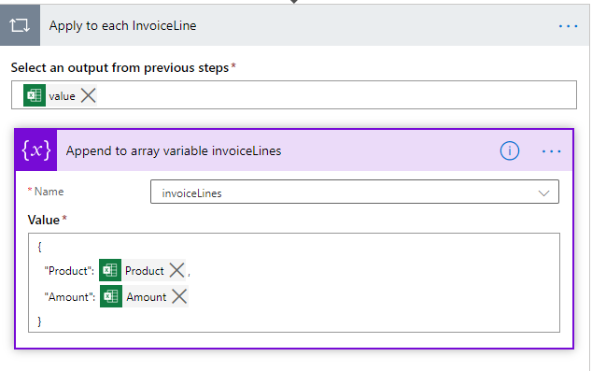

1. You will now update **the Populate a Microsoft Word template** action with this array. Select this action and click on the **Switch to input entire array** button:

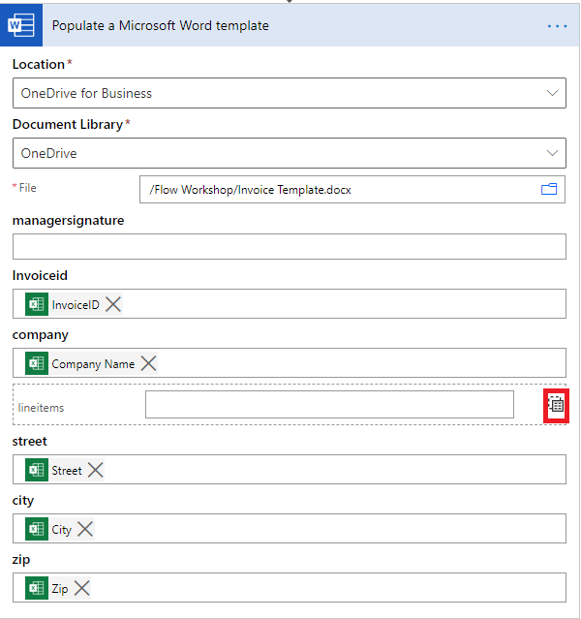

1. Store your array in this area:

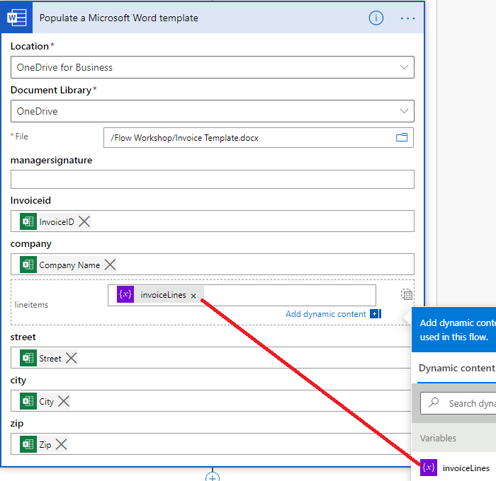

1. Run the Flow and check the generated documents. You should now see the invoice line items:

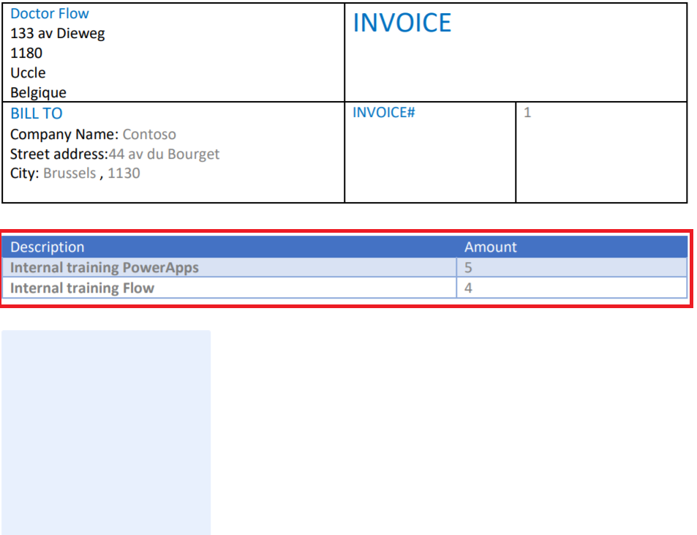

1. We will now display the signature portion of the document. Create a jpeg file with your name and signature, and upload it the Documents folder of your OneDrive for business. For instance, our signature looks like this:



1. In the beginning section of the Flow, add a **OneDrive for business** action **Get file content using path** and pass your signature file path:

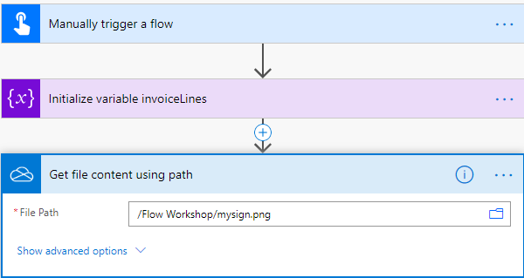

1. Edit the existing action **Populate a Microsoft Word template** action and in the **managersignature** field, pass your signature content:

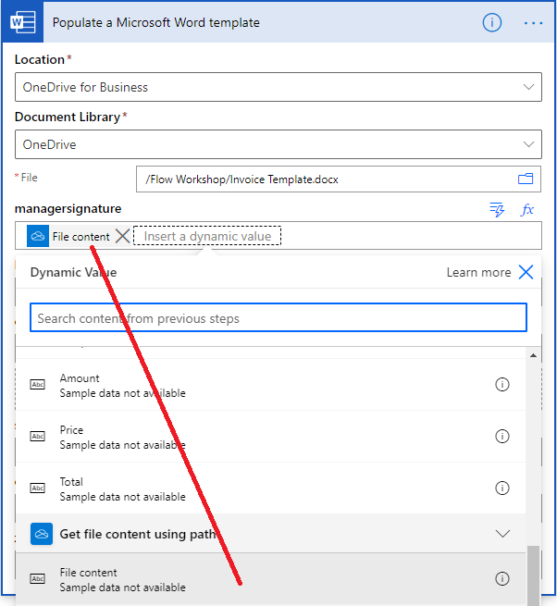

1. Test your Flow and check one the generated document, the signature should now be visible:

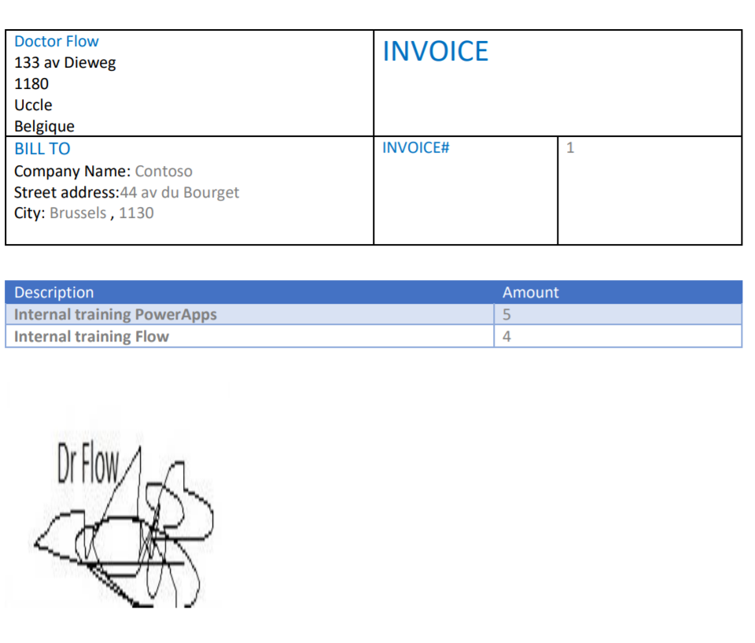

**We need your feedback**

Do you want to report an issue or to suggest something? We need your feedback: <https://github.com/Power-Automate-in-a-day/Training-by-the-community/issues>